WEBSITE NAME: QatarOne

**SUGGESTED/AVAILABLE DOMAIN NAME/URL**: [http://QatarOne.com](http://qatarone.com), [http://QatarOne-Qa.com](http://qatarone-qa.com), [http://QatarOne.com.qa](http://qatarone.com.qa)

**PROJECT TITLE:** CUSTOMIZEDRESPONSIVE WEBSITE BUNDLE IN A SINGLE WEBSITE: ECOMMERCE AND JOBSEEKER

**TYPE OF WEBSITE:** E-COMMERCE, COMMUNITY, CONTENT MANAGEMENT SYSTEM (CMS), CLASSIFIED +ADS (JOBSEEKER)

**LANGUAGES TO BE USED:** HTML4, HTML5, CSS2, CSS3, JQUERY, JAVASCRIPT, AJAX, PHP and SQL.

**TIME FRAME:** 2-3 months

**OVERVIEW**

Advances in the fields of computer science, cognitive learning theory, artificial intelligence, and interactive multimedia have converged to enable highly effective on-line learning systems. These systems are simultaneously increasing learner skills and knowledge while reducing development and delivery costs as compared to traditional methods. Even today, some considerable time after the so called ‘dot com/internet revolution’, electronic commerce (ecommerce) remains a relatively new, emerging and constantly changing area of business management and information technology. There has been and continues to be much publicity and discussion about e-commerce. In order to understand electronic commerce it is important to identify the different terms that are used, and to assess their origin and usage.

Electronic commerce is sharing business information, maintaining business relationships and conducting business transactions by means of telecommunications networks.The wide range of business activities related to e-commerce brought about a range of other new terms and phrases to describe the internet phenomenon in other business sectors. Some of these focus on selling and purchasing products from on-line stores on the internet. A person sitting on his chair in front of a computer can access all the facilities of the Internet to buy or sell the products. The main advantage of e-commerce over traditional commerce is the user can browse online shops, compare prices and order merchandise sitting at home on their PC.

The proposed website is an ecommerce site that is all about using the Internet to do business better and faster. It is about giving customers controlled access to computer systems and letting people serve themselves. It provides the user to view and search different product categories, post and reviews, post comments and review products, register to membership as basic and upgraded user, post product to sell, and manage users account. The proposed website is not only for selling products, it has also a feature of searching a job that fits to the skill of the user, and for those employers who wants to advertise or post an available job position. The website also has news, and event section.

The Developers will create a unique customized website that is responsive (RWD). It has the asbility to change layout automatically depending on the device used even without the interference of the user. No CMS will be used in making the website in order for it to be original and different compared to others. They will code manually using tools such as Adobe Dreamweaver especially notepad++ in order to ensure that the website’s codes is neat, organized and does not contain non-essentials codes. They will use the latest technology in web development in order for the website not to fall behind in terms of design and functionality. They will prioritize the use of Languages HTML5, CSS3 and jQuery (JS library) in order for the website to be considered as fresh and chic.

The website will be divided into two sides: Ecommerce site and the Jobseeker site. Ecommerce website will contains the latest products being advertised by a specific seller. It will also be a venue for different online advertising. There are three types of accounts associated with every transaction in the site. A guest account can only view products, posts or comments. These users have a very limited access to other pages and features of the site. For regular accounts, they can advertise their own products but it is limited to up to three (3) posting of products. They can also view products descriptions, posts and comments, and they can rate or review products. This account has a limited access also to user accounts and other pages and features of the website. With the upgraded account, the user can post and advertise their products without limitations. They have full access to all pages of the site including restricted pages to the regular and guest accounts.

On the other hand, the Jobseeker site will contain latest trends about jobs posted by the different employers or companies. It will also be a place for job searching and job fairs for the different users of the site. For guest account, they can only view jobs, posts or comments and they have a very limited access to the site features. Regular accounts are divided into two: Employer and Job Searcher. Employers can post and advertise jobs for up to three only, more than that needs an account upgrade. They can view and review jobs, post comments, view applicants and other pages of the site but there is also a limitation when it comes to the advanced features of the site. Job Searcher can find and apply for a job posted by the employer for up to three (3) applications only, more than that needs an upgrade of his/her membership. To sum up, guest and regular accounts have a limited access to the site pages and features while the upgraded accounts have a full access to user accounts and advanced site features. Premium employer has the ability to post and advertise jobs unlimited and can review applicant’s information while the Premium Job Searcher can apply for jobs without limit.

Payment Methods for upgrading user memberships will be done through PayPal, Credit Card or Bank Accounts which are the most commonly used type of online payment transactions today because it is secured and fast. Site Revenue will come from the advertisements of different companies or businesses and through membership upgrades from regular accounts to premium user. In all, the website can be considered as big as compared to other site because it is a combination of Ecommerce website with community, content management system and classified ads for jobs advertising.

**CONTENTS OF THE SYSTEM**

Product Categories and Sub Categories

**FOR ECOMMERCE**

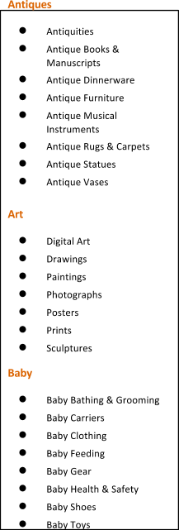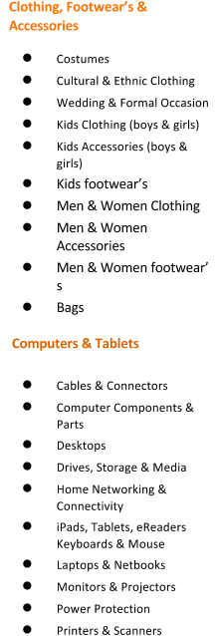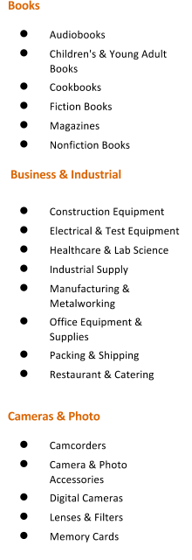

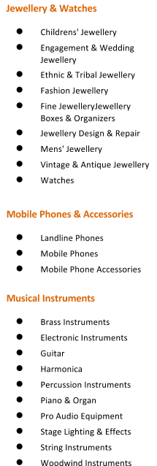

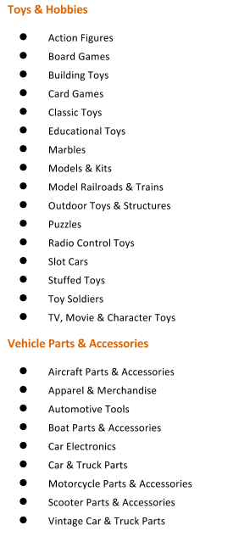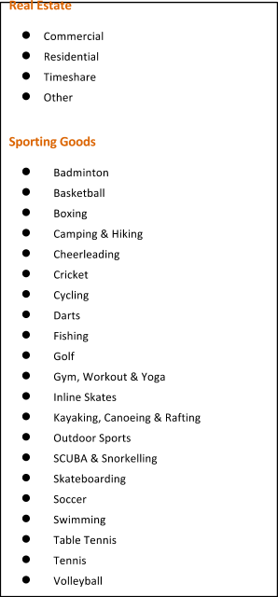

**FOR JOBSEEKER**

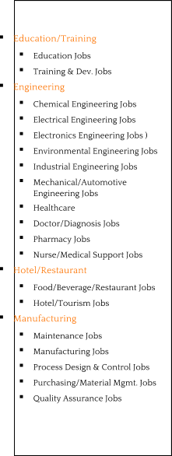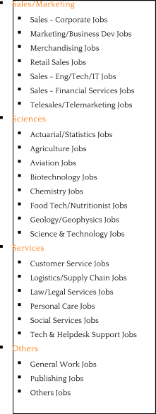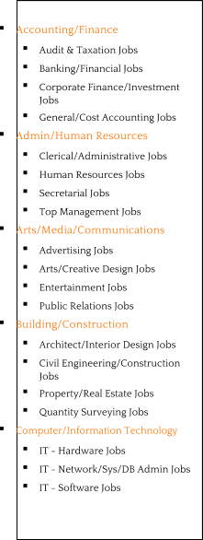

**Other Sections as per the Design**

* Fixed Ad Space Area
* Events Area
* News Page
* Contact Us Page
* Sitemap
* Google Map
* Terms of Use
* Privacy Policy
* FAQS (Frequently Asked Questions)

***FEATURES OF THE WEBSITE***

**Responsive Design**

* Able to run in almost all of the devices(tablets, phablets, smartphones, laptops and de
* sktops)
* Layout will automatically change depending on the device

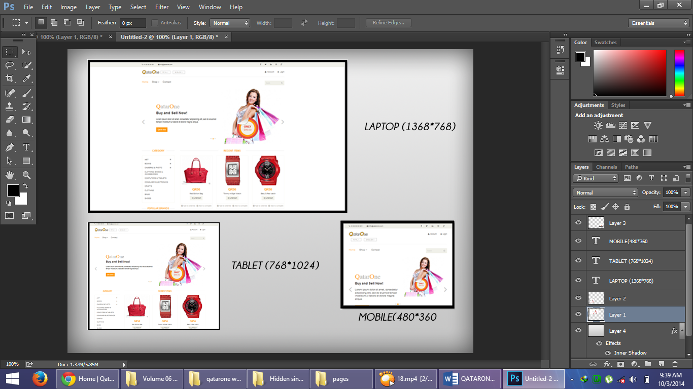

**Multilanguage**

Website may be Arabic or English depending on the preference of User

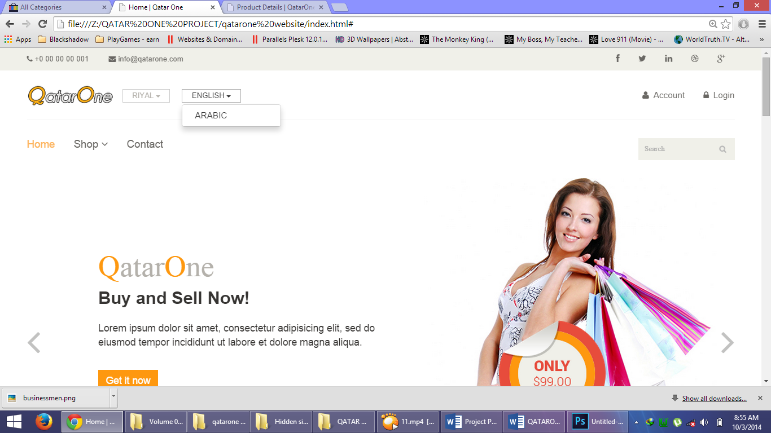

**Currency Changer**

Website may display US Dollars, Euro, Pounds, Dinar or Riyal depending on the preference of User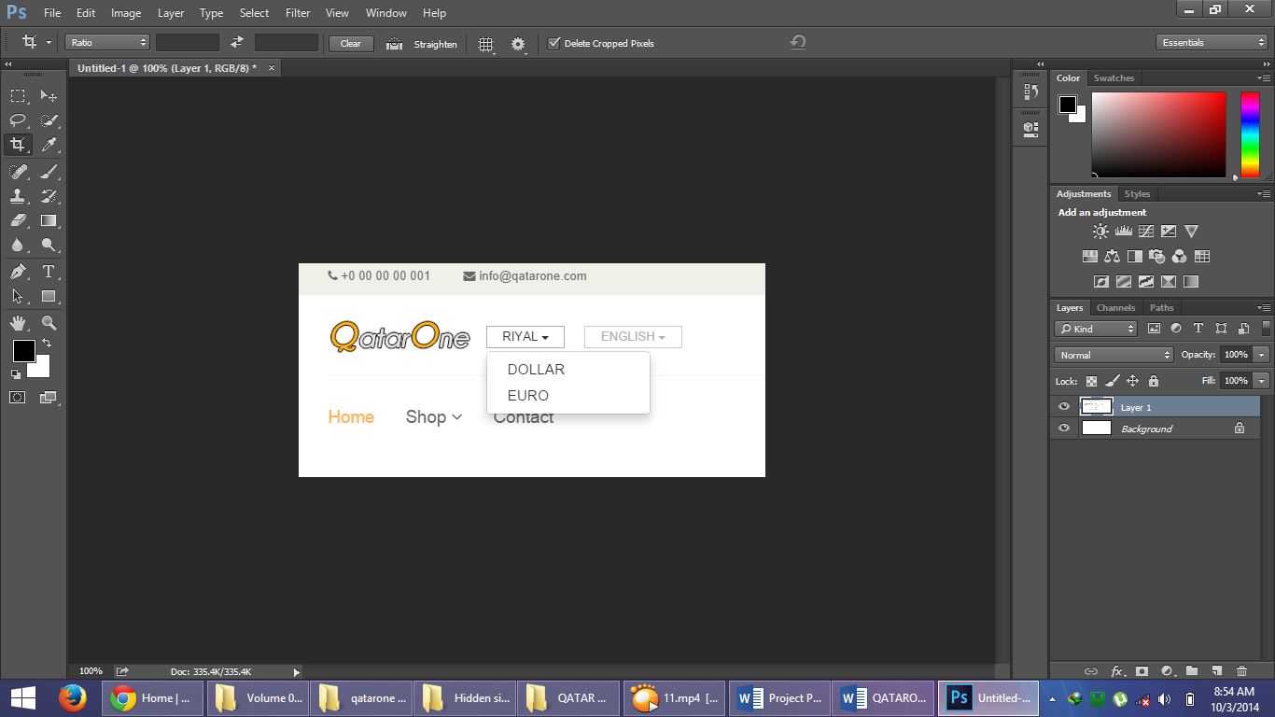

**Membership Types and Restrictions**

**GUEST**

* View products
* View jobs/classified ads
* View other pages
* Can Register

**REGULAR ACCOUNTS**

**ECOMMERCE MEMBER**

* MAIN FEATURE: **Limited posting of products (3 products)**
* View products
* View other pages (Ecommerce Side)
* Can comment on posts or products
* Can rate products
* Can review products
* Limited Access to User Accounts

**JOBSEEKER**

* MAIN FEATURE: **Limited application of jobs (3 jobs)**
* View jobs
* View other pages (Jobseeker Side)
* Can comment on posts
* Limited Access to User Accounts

**JOB EMPLOYER**

* MAIN FEATURE: **Limited posting of jobs (3 jobs)**
* View applicants
* View other pages(Job Employer Side)
* Can send message to applicants
* Limited Access to User Accounts

**UPGRADED ACCOUNT**

**PREMIUM ECOMMERCE MEMBER**

* MAIN FEATURE: **Unlimited posting of products**
* View products
* View other pages (Ecommerce Side)
* Can comment on posts or products
* Can rate products
* Can review products
* Full Access to User Accounts

**PREMIUM JOBSEEKER**

* MAIN FEATURE: **Unlimited Job Application**
* View jobs
* View other pages (Jobseeker Side)
* Can comment on posts
* Full Access to User Accounts

**PREMIUM JOB EMPLOYER**

* MAIN FEATURE: **Unlimited posting of JOBS**
* View applicants
* View other pages(Job employer Side)
* Can send message to applicants
* Full Access to User Accounts

**NOTE:** *Memberships are divided into seven (7) categories in order to specify the main purpose of the user. If he/she registers at the ecommerce side of the website, meaning he/she is either looking for products and not for a job. He/she may either be a buyer or seller. If he/she wants to post his/her product online and he/she has several products to post then he/she should upgrade his account in order to do so. A premium user whether he/she is a Premium Ecommerce Member, Premium Jobseeker or Premium Job Employer has several privileges not exclusive to those who are regular. They can also access some pages which are not shown to regular users or guests.*

*A user may register at the ecommerce side and also on the jobseeker side separately. This will not complicate things because there are separate database tables for each side.*

**MORE SITE REVENUE!** *Because a user may upgrade twice for different side (Ecommerce and Jobs) of website instead of single upgrade. Meaning if he wants to apply or post (depending on his/her role) more than three jobs then he/she needs to upgrade to Premium Jobseeker or Premium Job Employer. If he/she wanted to post more than three products online, then he/she also needs to upgrade his/her account as a Regular Ecommerce Member to a Premium Ecommerce Member.* ***TWO UPGRADES INSTEAD ON THE USUAL******ONE!!!***

**ADVERTISEMENT/FIXED ADS**

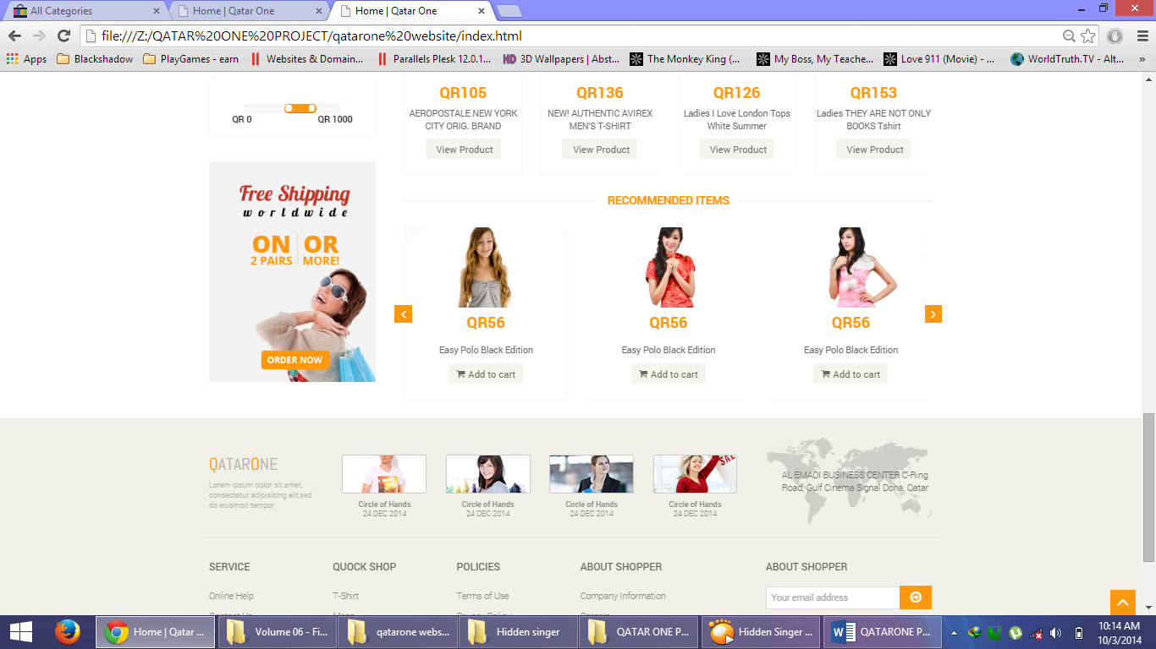

**EVEN MORE SITE REVENUE!** *Companies or any individual may apply to the fixed advertisement in the website, they have several choices starting from the banner/ads size, location of advertisement (homepage, products page, all pages and others) and duration (1 week, 1 month and other options). As soon as the advertisement’s time is finished, it will be taken down and the location of that advertisement will be declared available/open to other advertisement.*

**WEBSITE**

INDEX PAGE

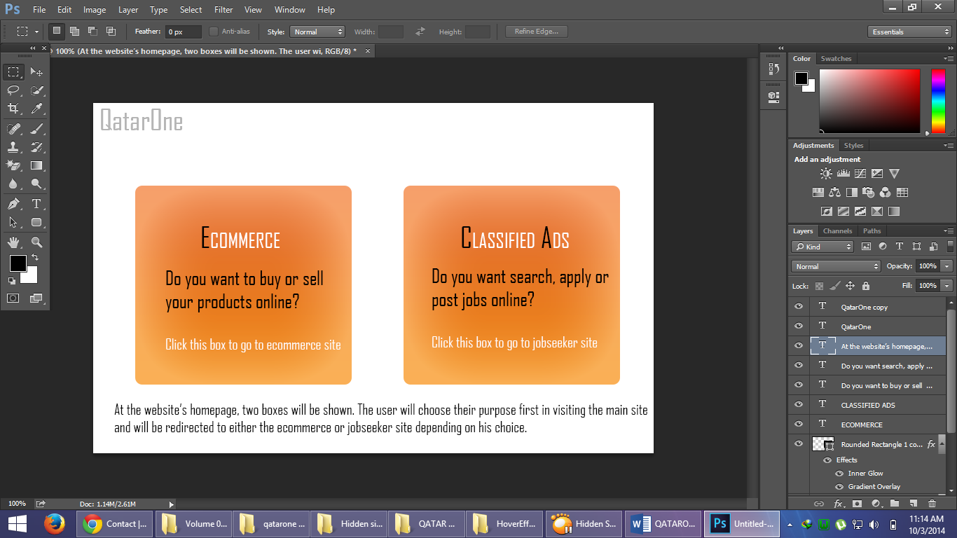

FULLY FLEDGE SLIDER AND AMAZING SEARCH BAR

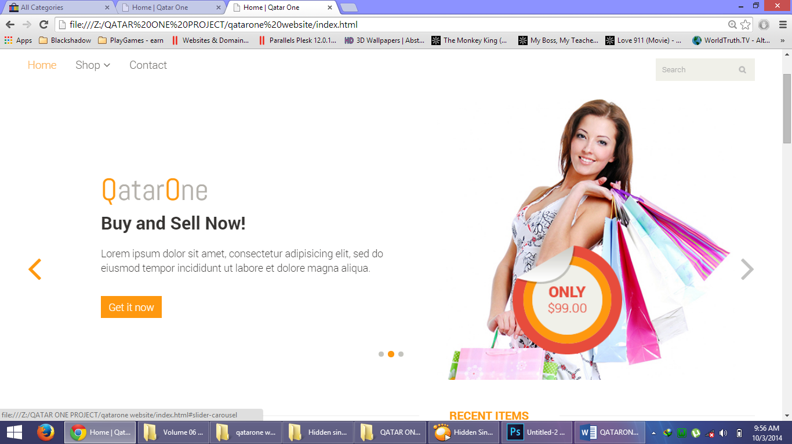

The slider of the website will display featured or new products/jobs automatically. It can handle up to 20 high definition images and text can also be inserted in the website.

RECENT ITEMS POSTED WILL BE DISPLAYED

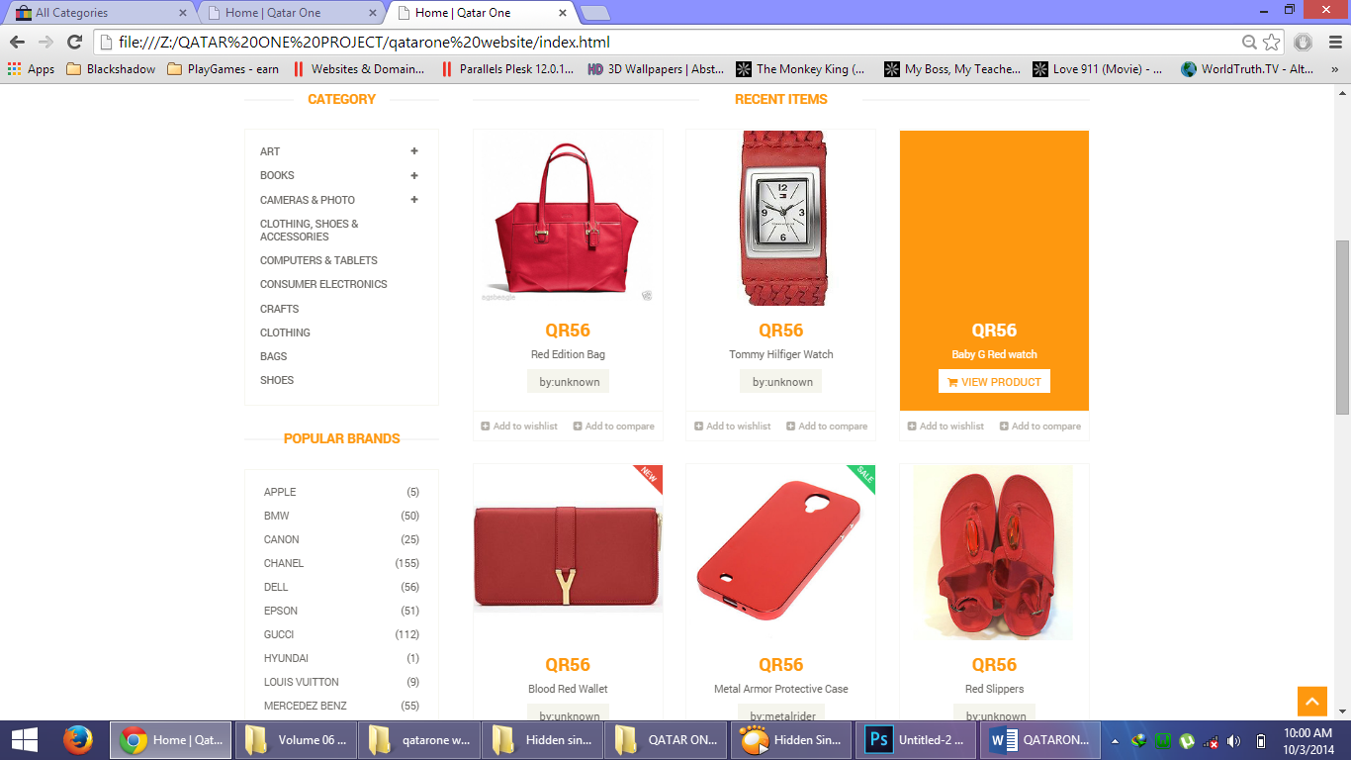

Recent items will be displayed. It includes the price, the name of the product, the seller and it can also handle descriptions/contents and lastly it has a hover effect (see third product).

CATEGORIES TAB DISPLAY, RECOMMENDED ITEMS

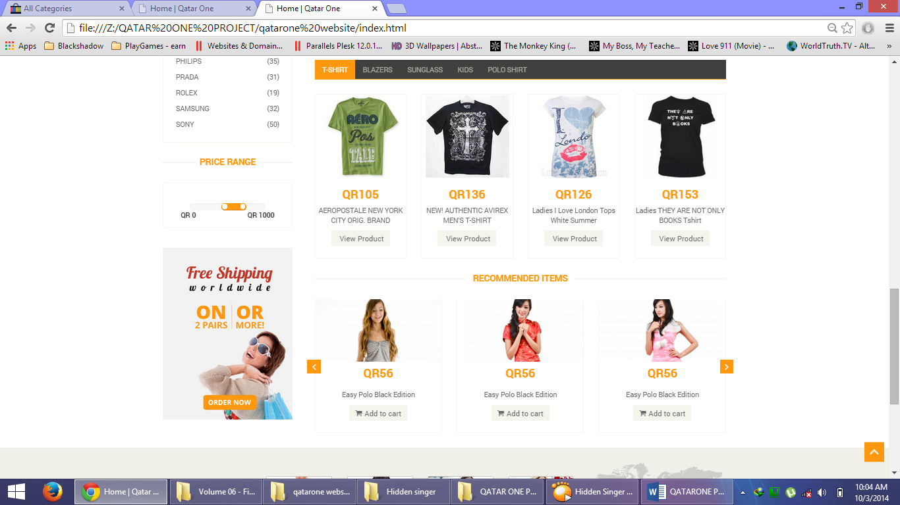

Suggested/Recommended Products will be displayed based on their popularity as well as a category tab display for some categories.

SPECIFIC CATEGORY (PRODUCT) WITH PAGING

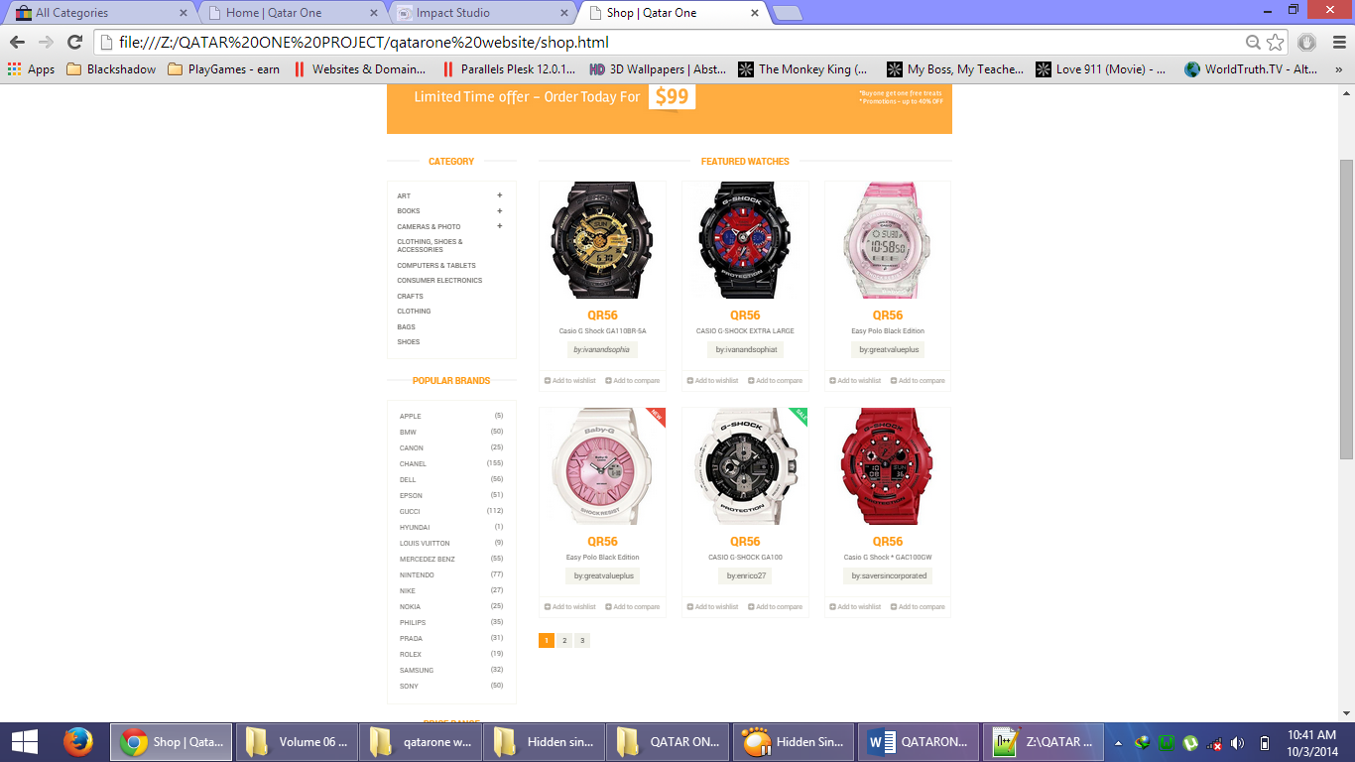

SINGLE PRODUCT DISPLAY



PRODUCTS FILTER BY CATEGORIES, BRAND OR PRICE RANGE

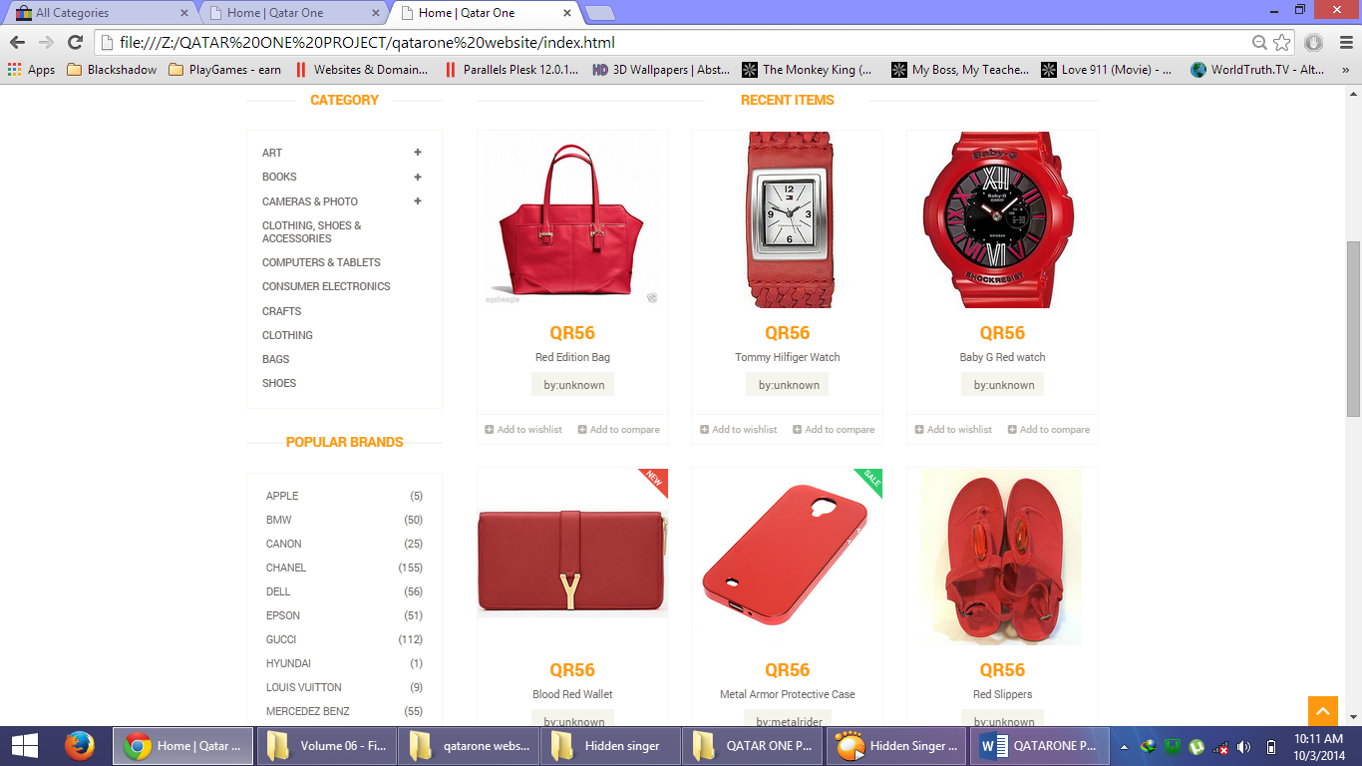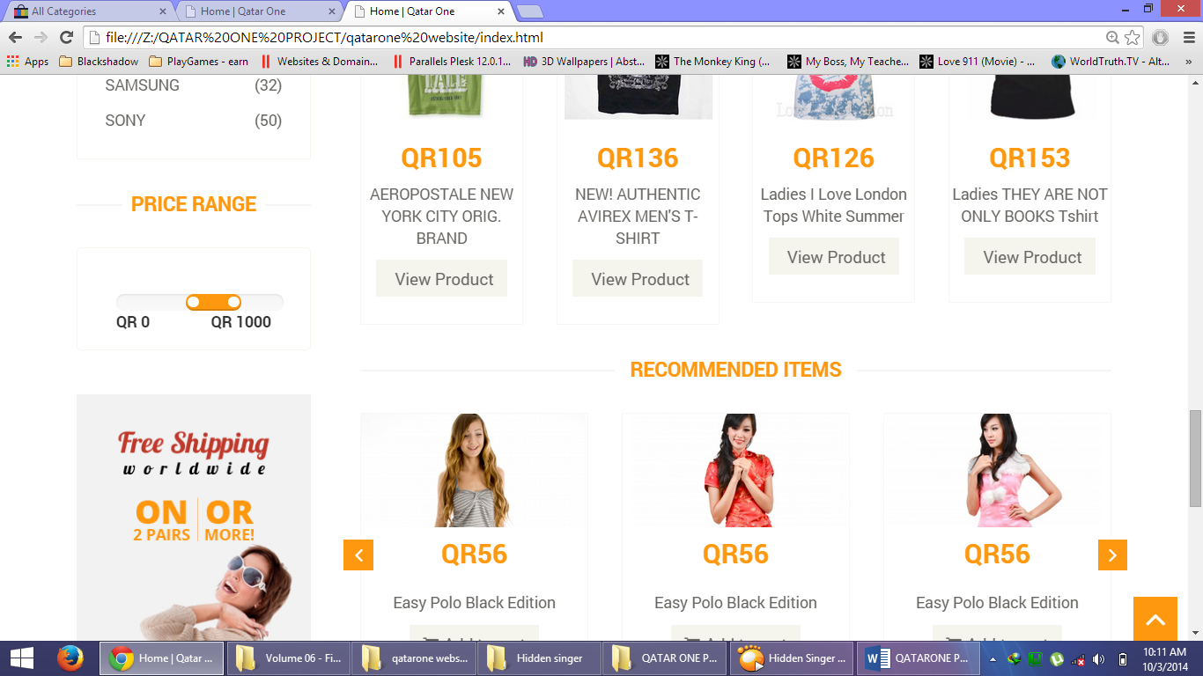

Products displayed may be viewed by categories, brand, or price range set by the user.

NEWSLETTER SUBSCRTIPTION

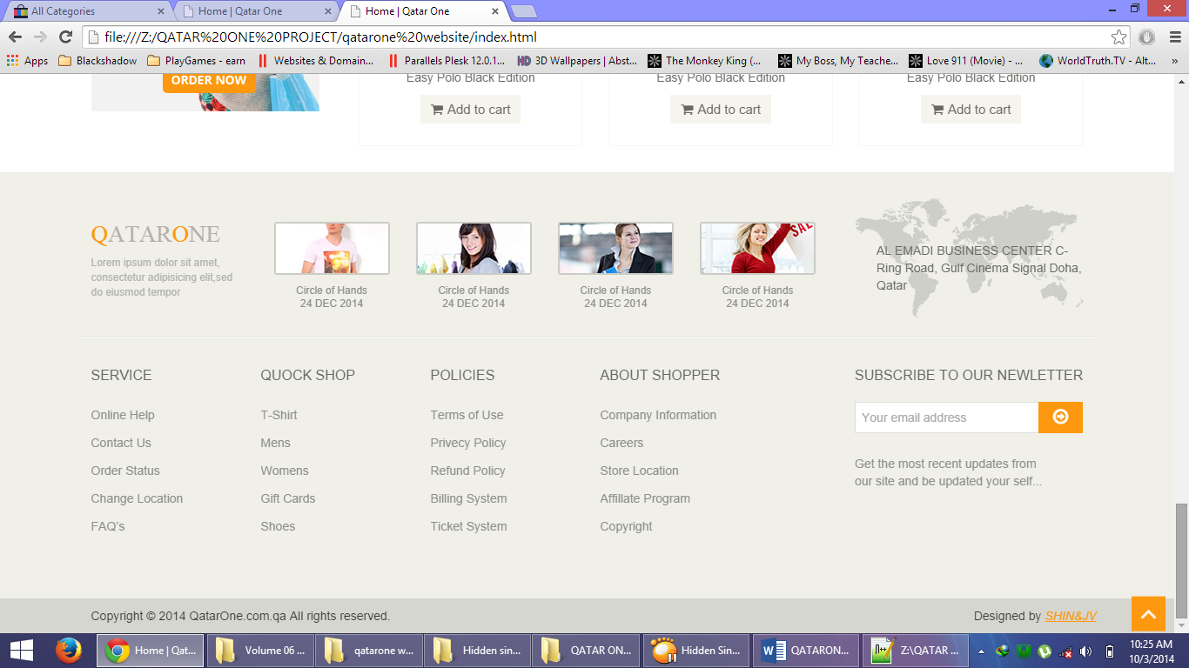

Newsletter/Updates will be sent to registered users who subscribed to the website. They will receive updates and news about the latest events and products as well as the recent announcements.

SOCIAL ICONS

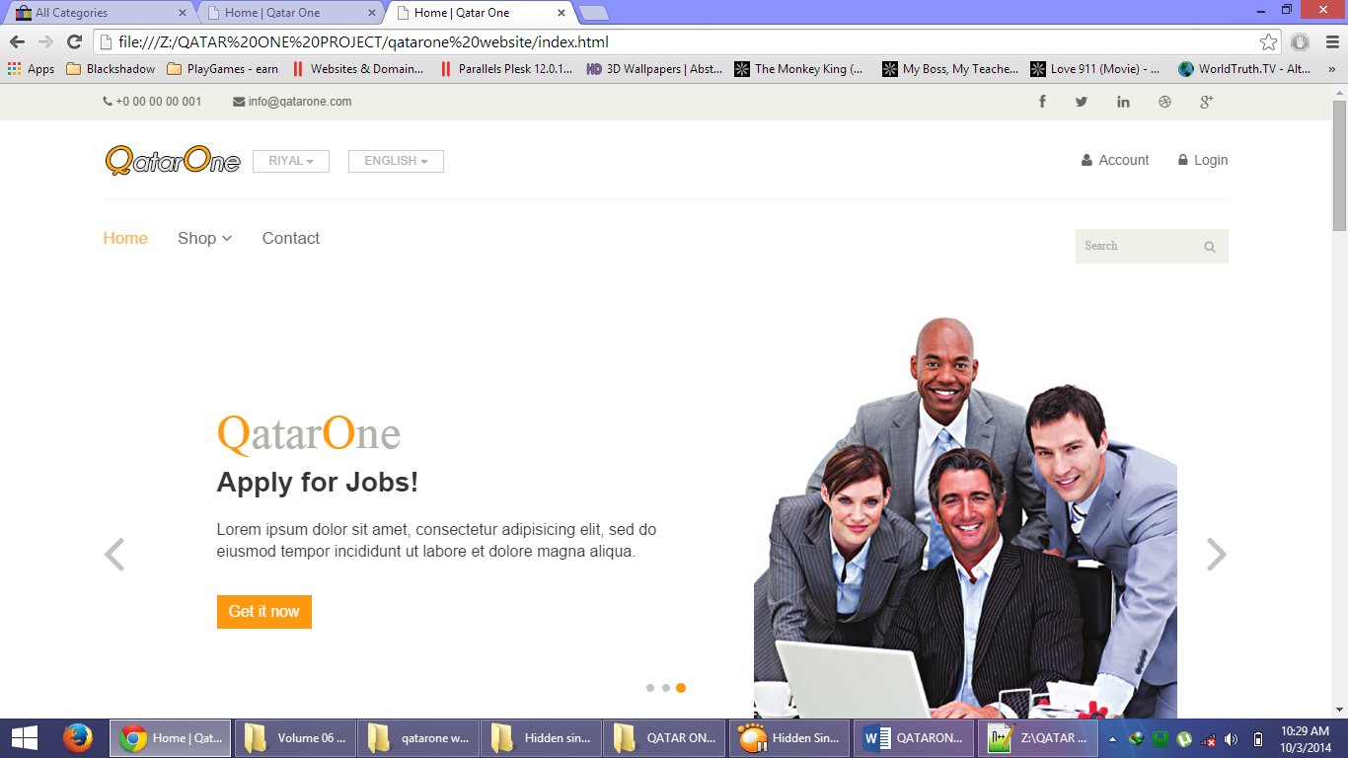

The website has social icons which has a very important role in making the site popular/well known.

MINIMALISTIC SIGN IN/UP PAGE

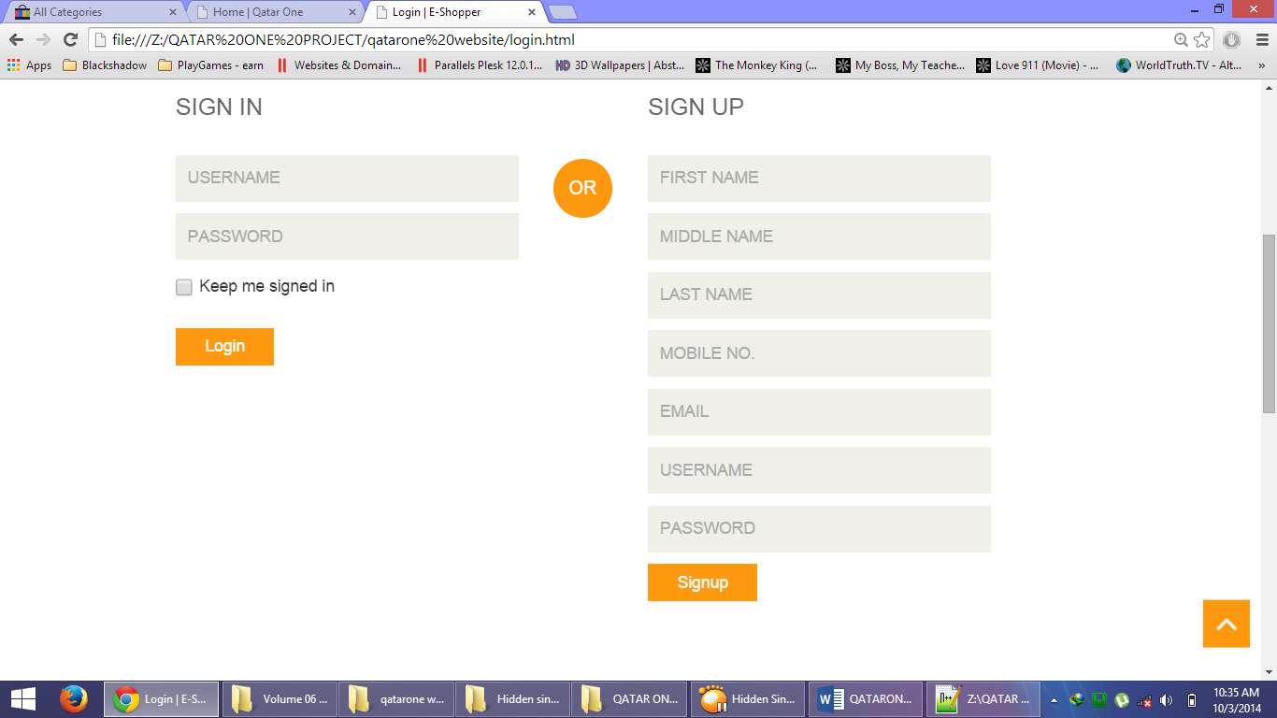

PRESENTABLE CONTACT PAGE

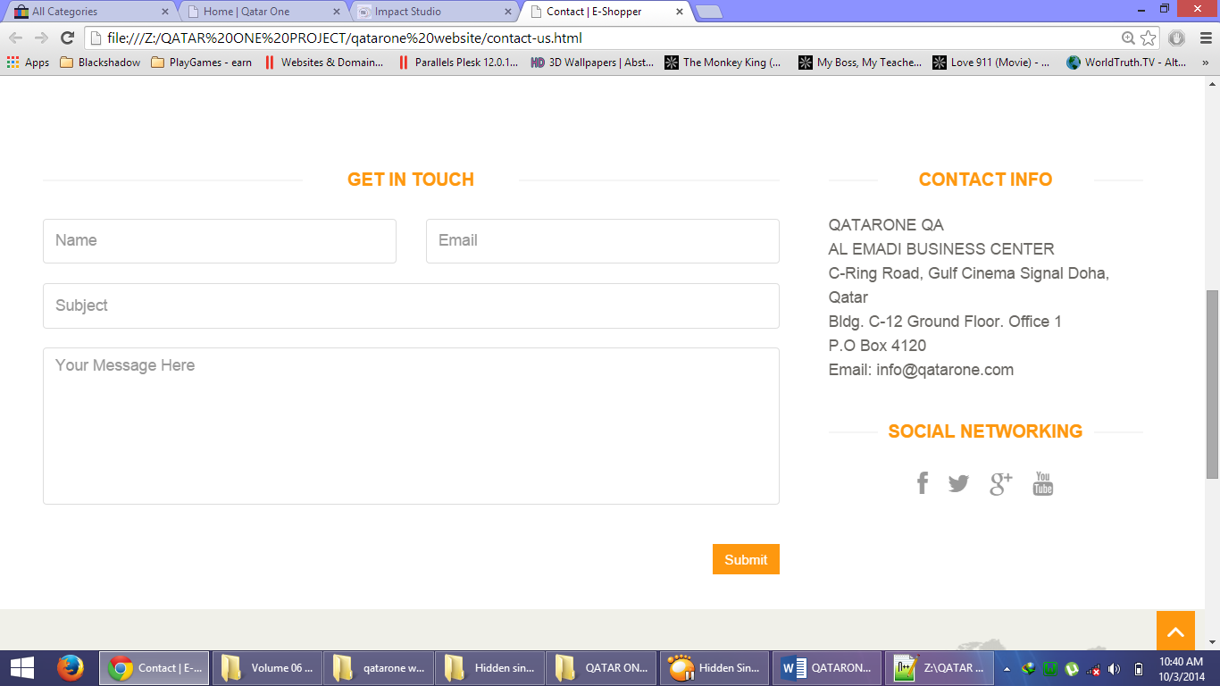

**Other features**

**Site Testimonial**

* There will be a site testimonial feature wherein user can leave/post their good feedbacks

**FRONT-END PAGE FLOW/TRANSACTION FLOW**

**A.1 E-COMMERCE SITE (Products Advertising)**

**ACCOUNTS/FLOW TASKS/RESTRICTIONS**































































**FLOW -Visit site**

1. For ***Registered Users***:

* Regular Account→ display Login Form → display homepage → post product up to 3 only→limited access to the site features.
* Upgraded Account →display Login Form →display homepage →post products more than 3→full-access to the site features.

2. For ***Guest***, select:

* View site only (with restrictions and very limited access to the site features/pages)
* Registration →display membership form→ select account:

- Regular Account → registration only

- Upgraded Account → registration and Payment

**A.2 JOBSEEKER SITE (Job Advertising and Application)**

**ACCOUNTS/FLOW TASKS/RESTRICTIONS**



























































































































**FLOW -Visit site**

1. For ***Registered Users***:

EMPLOYER

* Regular Account→ display Login Form → display homepage → post jobs up to 3 only→limited access to the site features.
* Upgraded Account →display Login Form →display homepage →post jobs more than 3→full-access to the site features.

JOB SEARCHER

* Regular Account→ display Login Form → display homepage → apply for job up to 3 only→limited access to the site features.
* Upgraded Account →display Login Form →display homepage →apply for more than 3 jobs→full-access to the site features.

2. For ***Guest***, select:

* View site only (with restrictions and very limited access to the site features/pages)
* Registration →display membership form→ select account:

- Regular Account → registration only

- Upgraded Account → registration and Payment

**Project Development**

|  |  |  |  |  |  |  |  |  |  |  |  |  |  |
| --- | --- | --- | --- | --- | --- | --- | --- | --- | --- | --- | --- | --- | --- |
| Project Milestone |  |  |  |  |  |  |  |  |  |  |  |  |  |
| WEEK | **1** | **2** | **3** | **4** | **1** | **2** | **3** | **4** | **1** | **2** | **3** | **4** |  |
| 1. Requirements Analysis, Gathering of Data |  |  |  |  |  |  |  |  |  |  |  |  |  |
| 2. Project Proposal |  |  |  |  |  |  |  |  |  |  |  |  |  |
| 3. Approval |  |  |  |  |  |  |  |  |  |  |  |  |  |
| 4. Revisions |  |  |  |  |  |  |  |  |  |  |  |  |  |
| 5. Development Phase |  |  |  |  |  |  |  |  |  |  |  |  |  |
| 6. Approval |  |  |  |  |  |  |  |  |  |  |  |  |  |
| 7. Revisions |  |  |  |  |  |  |  |  |  |  |  |  |  |
| 8. Acceptance |  |  |  |  |  |  |  |  |  |  |  |  |  |
| 9. Testing/Deployment |  |  |  |  |  |  |  |  |  |  |  |  |  |
| 10. Maintenance |  |  |  |  |  |  |  |  |  |  |  |  |  |
| **TIME FRAME** | October 1-31 |  |  |  | November 1-30 |  |  |  | December 1-20 |  |  |  | **Dec 21 and so on** |

NOTE: This will be updated as time goes on.

**Website Cost + Development Cost**

|  |  |
| --- | --- |
| FACTORS | Cost |
| Web Developers | QR 2000 |
| Web planning, design and development time (3 months) |  |
| Responsive Website Design (Mobile, Tablet, Laptop, Desktop) | QR 500 |
| Ecommerce Website (Transactions and Products) | QR 1200 |
| Jobseeker Website (Transactions and Jobs) | QR 1200 |
| Administrator (BackEnd) | QR 500 |
| User Accounts (7 types of memberships) | QR 500 |
| Advanced Searching (Ecommerce and Jobseeker) | QR 500 |
| Basic Search Engine Optimization (SEO) | QR 300 |
| Website Optimization (Decrease of Website’s Size & Loading Time) | QR 400 |
| Language Options (Arabic or English) | QR 500 |
| MAINTENANCE (1 year) | FREE |
| Total: | **QR 7600** |

**NOTE:** QatarOne is a proposed website composed of two large websites (eCommerce and JobSeeker) merged into one. It is very huge and complicated because there are two times the amount of contents, categories and pictures instead of the usual one.

* Maintenance involves fixing errors and bugs which is originally found in the Website and is caused by the Developers or other factors that affects it (codes, plugins, jquery plugins and other php codes). Errors or Bugs caused by other people besides the developers is out of the question and is not included in the maintenance phase.

ADDITIONAL FEATURES

|  |  |  |  |
| --- | --- | --- | --- |
| Features | Description/Advantage of Having one | Cost |  |
| Website Testimonial | This will display a list of good testimonials from registered users of the site. It will greatly affect the trust rating of the website because of the testimonials made by the users. | QR 300 |  |
| Messaging System (User to user) | This will allow to site to have a messaging system which allows the user to message another user for inquiry or any other purpose. It will drastically improve the communication between users and the transaction will be processed more smoothly. | QR 700 |  |
| Additional Page | Add an additional page which has specific contents, images or post. | Depends on the contents and difficulty |  |
| Ecommerce or Jobseeker Forum | A forum will greatly increase the trust rating of the website and will allow user to user communication. | QR 1000 |  |
| Currency Converter/Calculator (Selected currency only, not all) | Allows the converting of currency depending on the type of money and rates as well as computation of money. | QR 600 |  |

ADDITIONAL SERVICE

|  |  |  |  |  |  |
| --- | --- | --- | --- | --- | --- |
| Services | Description | Duration |  |  | Cost |
| Website Administrator & Moderator | The Developers will manage the said website. They will add, edit, and delete the contents, images and other things which is not appropriate and not essential to the website. They will monitor the website’s health, security, users, posts, products and other things and will report back to the client if something goes wrong.  As a bonus, they will slowly upgrade the website’s design and layout for free as time goes on in order to for the website to stand the test of time. Meaning they will change outdated codes and features which are found in the site.  They are also in charge of deleting rude comments and testimonials as well as blacklisting users which does harm to the website. | Monthly |  | QR 800 |  |